# Part1

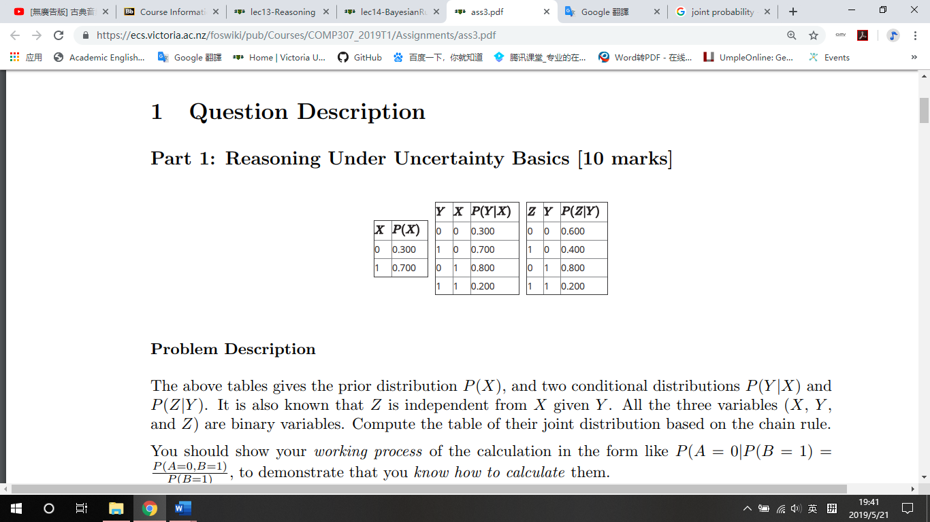

1.

use the product rule:

P(X, Y) = P(Y) * P(X | Y) = P(X) * P(Y | X)

P(X = 0, Y = 0) = P(X = 0) * P(Y=0 | X=0) = 0.3 * 0.3 = 0.9

P(X = 0, Y = 1) = P(X = 0) * P(Y=1 | X=0) = 0.3 * 0.7 = 0.21

P(X = 1, Y = 0) = P(X = 1) * P(Y=0 | X=1) = 0.7 * 0.8 = 0.56

P(X = 1, Y = 1) = P(X = 1) * P(Y=1 | X=1) = 0.7 * 0.2 = 0.14

2.

P(X = 1, Y = 0, Z = 0) = 0.336

use the product rule:

P(X, Z | Y) = P(X | Y) * P(Z | Y)

P(X, Y, Z) = P(Y) * P(X, Z | Y) = P(Y) * P(X | Y) * P(Z | Y) = P(X,Y) * P(Z | Y)

P(X=0, Y=0, Z=0) = P(X=0, Y=0) * P(Z=0 | Y=0) = 0.9 * 0.6 =0.054

P(X = 0, Y = 0, Z = 1) = 0.036

P(X = 0, Y = 1, Z = 0) = 0.168

P(X = 0, Y = 1, Z = 1) = 0.042

P(X = 1, Y = 0, Z = 0) = 0.336

P(X=1, Y=0, Z=1) = P(X=1, Y=0) * P(Z=1 | Y=0) = 0.56 * 0.4 =0.224

P(X=1, Y=1, Z=0) = P(X=1, Y=1) * P(Z=0 | Y=1) = 0.14 * 0.8 =0.112

P(X=1, Y=1, Z=1) = P(X=1, Y=1) * P(Z=1 | Y=1) = 0.14 * 0.2 =0.028

|  |  |  |  |
| --- | --- | --- | --- |
| X | Y | Z | P(X,Y,Z) |
| 0 | 0 | 0 | 0.054 |
| 0 | 0 | 1 | 0.036 |
| 0 | 1 | 0 | 0.168 |
| 0 | 1 | 1 | 0.042 |
| 1 | 0 | 0 | 0.336 |
| 1 | 0 | 1 | 0.224 |
| 1 | 1 | 0 | 0.112 |
| 1 | 1 | 1 | 0.028 |

3.

(i)

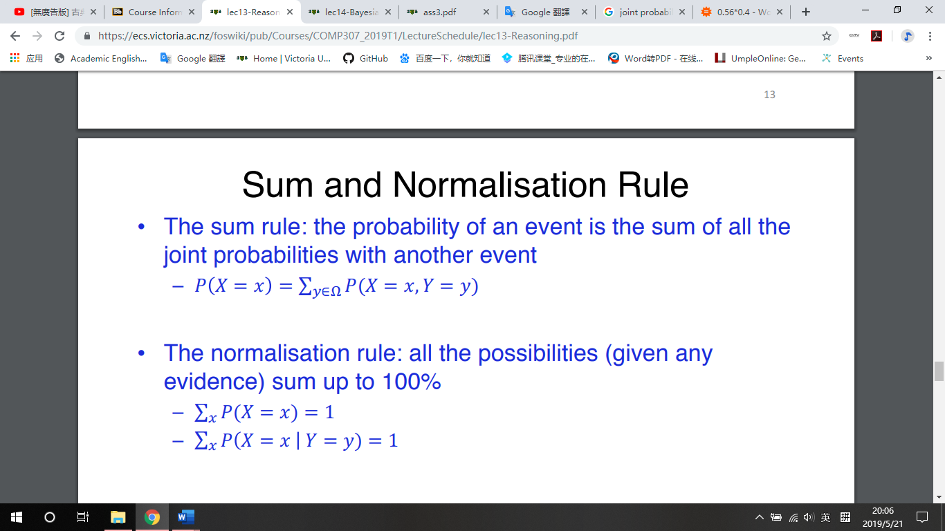

P(Z=0) = P(X=1, Y=1, Z=0)+ P(X = 1, Y = 0, Z = 0) + P(X=0, Y=0, Z=0) + P(X=0, Y=0, Z=0)= 0.112 +0.336 +0.168+0.054 = 0.67

P(X = 0, Z = 0) = P(X = 0, Y = 1, Z = 0) + P(X=0, Y=0, Z=0) =0.168+0.054 = 0.222

(ii)

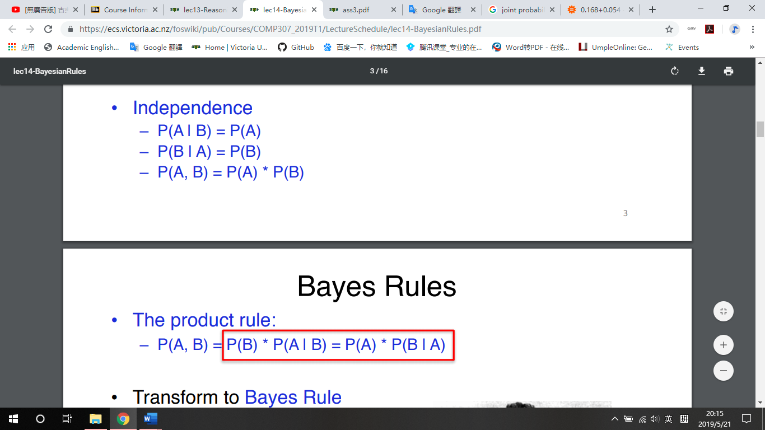

P(X=0) = P(X = 0, Z = 0) / P(Z=0) = 0.222/0.67 unequal 0.3 which means X and Z are not independent

4.

(i)

P(Z = 1) = P(X = 0, Y = 0, Z = 1)+ P(X = 0, Y = 1, Z = 1)+ P(X=1, Y=0, Z=1)+ P(X=1, Y=1, Z=1)

=0.036+0.042+0.224+0.028 =0.33

P(X = 1, Y = 0|Z = 1) = P(X = 1, Y = 0, Z = 1) / P(Z = 1) = 0.224/0.33 = 0.679

(ii)

P(Y = 0, Z = 0) = P(X=0, Y=0, Z=0)+ P(X = 1, Y = 0, Z = 0) =0.054+0.336 =0.39

P(X = 0 | Y = 0, Z = 0) = P(X = 0, Y = 0, Z = 0) / P(Y = 0, Z = 0) = 0.054/0.39=0.138

# Part2

1.

P(F1 = 1| C = 1) = 0.6730769230769231, P(F1 = 1| C = 0) = 0.36, P(F1 = 0| C = 1) = 0.34615384615384615, P(F1 = 0| C = 0) = 0.6466666666666666

P(F2 = 1| C = 1) = 0.5961538461538461, P(F2 = 1| C = 0) = 0.58, P(F2 = 0| C = 1) = 0.4230769230769231, P(F2 = 0| C = 0) = 0.4266666666666667

P(F3 = 1| C = 1) = 0.46153846153846156, P(F3 = 1| C = 0) = 0.3466666666666667, P(F3 = 0| C = 1) = 0.5576923076923077, P(F3 = 0| C = 0) = 0.66

P(F4 = 1| C = 1) = 0.6153846153846154, P(F4 = 1| C = 0) = 0.4, P(F4 = 0| C = 1) = 0.40384615384615385, P(F4 = 0| C = 0) = 0.6066666666666667

P(F5 = 1| C = 1) = 0.5, P(F5 = 1| C = 0) = 0.34, P(F5 = 0| C = 1) = 0.5192307692307693, P(F5 = 0| C = 0) = 0.6666666666666666

P(F6 = 1| C = 1) = 0.36538461538461536, P(F6 = 1| C = 0) = 0.47333333333333333, P(F6 = 0| C = 1) = 0.6538461538461539, P(F6 = 0| C = 0) = 0.5333333333333333

P(F7 = 1| C = 1) = 0.7884615384615384, P(F7 = 1| C = 0) = 0.5066666666666667, P(F7 = 0| C = 1) = 0.23076923076923078, P(F7 = 0| C = 0) = 0.5

P(F8 = 1| C = 1) = 0.7692307692307693, P(F8 = 1| C = 0) = 0.35333333333333333, P(F8 = 0| C = 1) = 0.25, P(F8 = 0| C = 0) = 0.6533333333333333

P(F9 = 1| C = 1) = 0.34615384615384615, P(F9 = 1| C = 0) = 0.24666666666666667, P(F9 = 0| C = 1) = 0.6730769230769231, P(F9 = 0| C = 0) = 0.76

P(F10 = 1| C = 1) = 0.6730769230769231, P(F10 = 1| C = 0) = 0.29333333333333333, P(F10 = 0| C = 1) = 0.34615384615384615, P(F10 = 0| C = 0) = 0.7133333333333334

P(F11 = 1| C = 1) = 0.6730769230769231, P(F11 = 1| C = 0) = 0.5866666666666667, P(F11 = 0| C = 1) = 0.34615384615384615, P(F11 = 0| C = 0) = 0.42

P(F12 = 1| C = 1) = 0.7884615384615384, P(F12 = 1| C = 0) = 0.34, P(F12 = 0| C = 1) = 0.23076923076923078, P(F12 = 0| C = 0) = 0.6666666666666666

2.

Probability for Spam is 4.563570134160374E-6 , Probability for non-spam is 4.954267164176628E-4, Non_Spam

Probability for Spam is 7.210346867817722E-5 , Probability for non-spam is 4.5438790152493946E-5, Spam

Probability for Spam is 2.337624408575223E-4 , Probability for non-spam is 1.3955766540710917E-4, Spam

Probability for Spam is 7.663585265070243E-6 , Probability for non-spam is 6.466481819829655E-4, Non_Spam

Probability for Spam is 7.7202748511879E-5 , Probability for non-spam is 1.0025583637879425E-4, Non_Spam

Probability for Spam is 7.434338745588349E-5 , Probability for non-spam is 5.026186824410612E-5, Spam

Probability for Spam is 5.124916761793711E-6 , Probability for non-spam is 3.540527014157241E-4, Non_Spam

Probability for Spam is 8.117842746585805E-5 , Probability for non-spam is 4.2357652476948595E-4, Non_Spam

Probability for Spam is 2.3376244085752235E-4 , Probability for non-spam is 4.10847332740555E-5, Spam

Probability for Spam is 2.8353542253659124E-5 , Probability for non-spam is 7.338396327966042E-4, Non_Spam

3. Naive Bayes algorithm for independent feature. The test results are not all correct that indicate they are not all independent.

# Part3

1.M for meeting, LT for lecture teaching, O for office, L for light, C for computer

|  |  |
| --- | --- |
| M | P(M) |
| 1 | 0.7 |
| 0 | 0.3 |

|  |  |
| --- | --- |
| LT | P(LT) |
| 1 | 0.6 |
| 0 | 0.4 |

|  |  |  |  |
| --- | --- | --- | --- |
| M | LT | O | P(O| M, LT) |
| 1 | 1 | 1 | 0.95 |
| 1 | 1 | 0 | 0.05 |
| 1 | 0 | 1 | 0.75 |
| 1 | 0 | 0 | 0.25 |
| 0 | 1 | 1 | 0.8 |
| 0 | 1 | 0 | 0.2 |
| 0 | 0 | 1 | 0.06 |
| 0 | 0 | 0 | 0.94 |

|  |  |  |
| --- | --- | --- |
| L | O | P(L|O) |
| 1 | 1 | 0.5 |
| 0 | 1 | 0.5 |
| 1 | 0 | 0.02 |
| 0 | 0 | 0.98 |

|  |  |  |
| --- | --- | --- |
| C | O | P(C|O) |
| 1 | 1 | 0.8 |
| 0 | 1 | 0.2 |
| 1 | 0 | 0.2 |
| 0 | 0 | 0.8 |

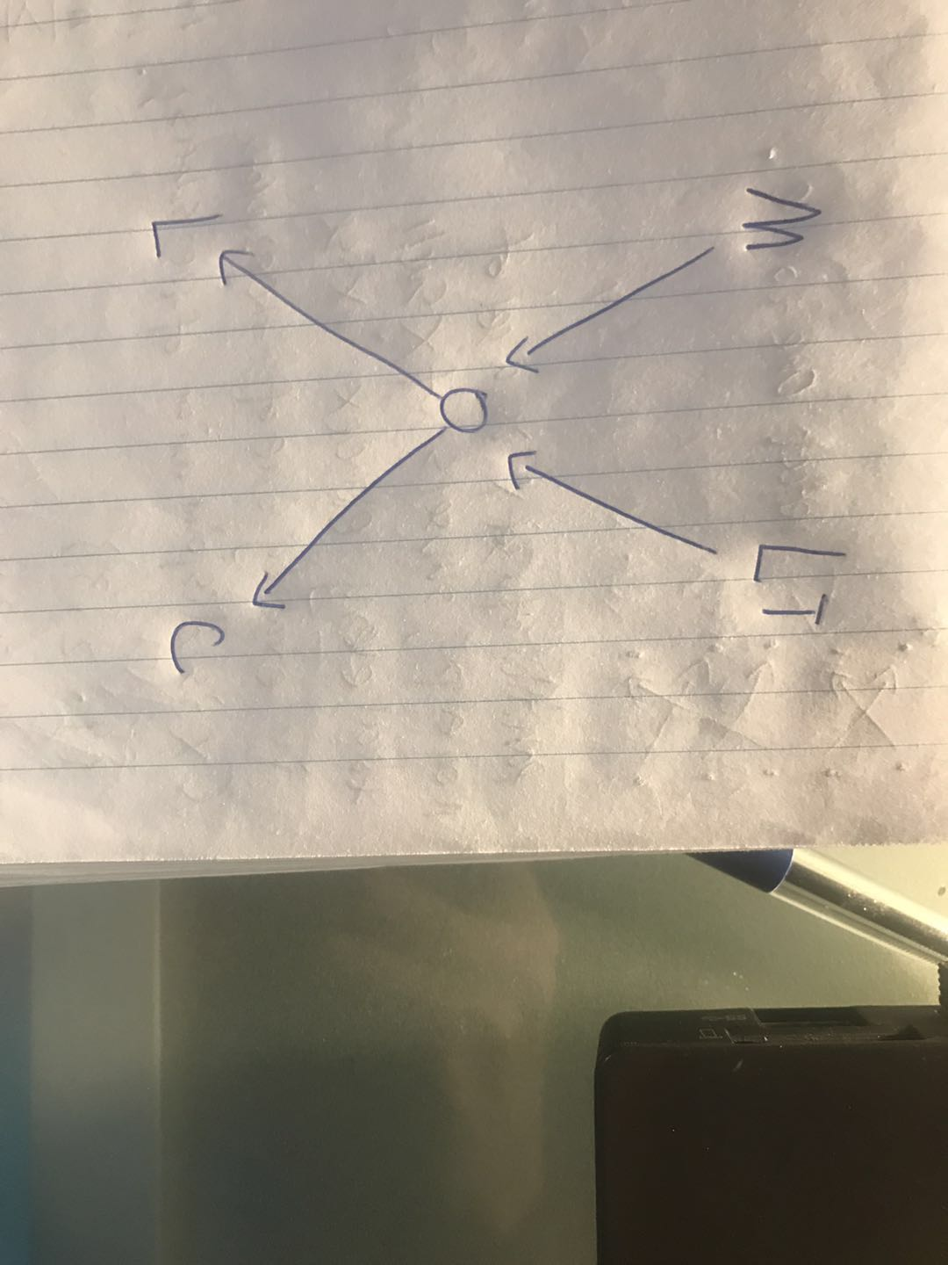

2. depend on above probability graph, half of them is CPT size

2/2 +2/2+8/2+4/4+4/2 =10

3. P(M=0) * P(LT=1) * P(O=1|M=0, LT=1)* P(L=0|O=1)* P(C=1|O=1)

0.3*0.6*0.8*0.5*0.8 = 0.0576

4. P(O|M=1, T=1) + P(O|M=1,T=0) + P(O|M=0,T=1) + P(O|M=0,T=0)

0.95*0.7*0.6+0.75*0.7*0.4+0.8*0.3*0.6+0.06*0.3*0.4=0.7602

5. P(C=1|O=1)*P(L=0|O=1) = 0.8*0.5 = 0.4

6. light and computer log on are dependent, we can not know if Rachels in office. Thus, there is not effect on the students belief that Rachels light is on.

# Part4

1(i).

Evidence variables: XRay

Hidden variables: Smoker, Cancer, Dyspnoea

query variables: Pollution

(ii).

choose c, join p,s,c,x then eliminate c. choose s join p,s,x ,then eliminate s.

(iii).

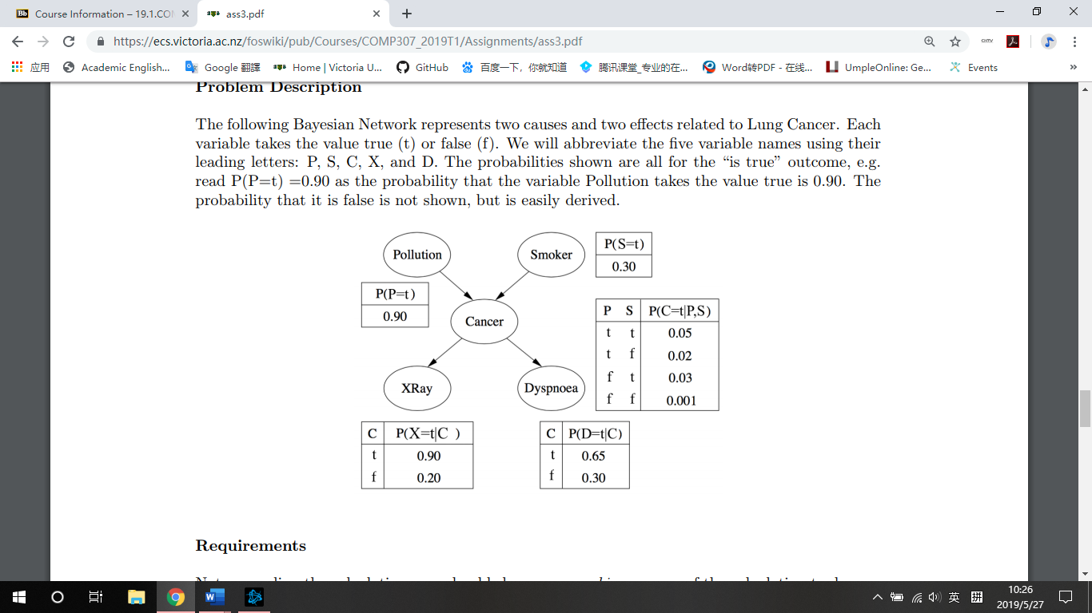

P(P=t| X=t) = P(P=t) * P(S=t) * P(C=t| P=t, S=t) * P(X=t |C=t)

+ P(P=t) * P(S=f) * P(C=t| P=t, S=f) * P(X=t| C=t)

+ P(P=t) * P(S=t) * P(C=f| P=t, S=t) * P(X=t| C=f)

+ P(P=t) * P(S=f) * P(C=f| P=t, S=f) * P(X=t| C=f) =

0.9*0.3*0.05*0.9+0.9*0.7*0.02*0.9+0.9*0.3*0.95*0.2+0.9*0.7*0.98*0.2=0.19827

P(P=f| X=t) =

P(P=f) * P(S=t) * P(C=t| P=f, S=t) * P(X=t| C=t)

+ P(P=f) * P(S=f) * P(C=t| P=f, S=f) * P(X=t| C=t)

+ P(P=f) * P(S=t) * P(C=f| P=f, S=t) * P(X=t| C=f)

+ P(P=f) * P(S=f) * P(C=t| P=f, S=f) * P(X=t| C=f) =

0.1*0.3*0.03*0.9+0.1*0.7*0.001*0.9+0.1*0.3*0.97*0.2+0.1*0.7*0.999*0.2=0.020679

P(p=t|X=t)/(P(p=t|X=t)+P(P=f|x=f))=0.19827/(0.19827+0.020679) = 0.906

2.

D and X, they got common cause.

P and X, P is indirect cause of X.

S and X, S is indirect cause of X.

3.

STEP1:

P(S|P) != P(P) P->S

STEP2:

P(C|P,C) != P(C)

P(C|P,S) != P(C|P)

P(C|P,S) = P(C|S) => P->C and S->C

STEP3:

P(X|P,S,C) != P(X)

P(X|P,S,C) = P(X|C) => C->X, no other link

STEP4:

P(D|P,S,C,X) !=P(D)

P(D|P,S,C,X) !=P(D|C)

P(D|P,S,C,X) !=P(D|X)

P(D|P,S,C,X) =P(D|C,X) => C->D,X->D no other link

